



Microsoft
Apollo Phase III
Functional Specification

Version 1.0

Table of Contents
1 Document Purpose 3
2 Introduction 4
2.1 Goals 4
2.2 Scope 5
2.2.1 In Scope 5
2.2.2 Out of Scope 5
3 Data Structure Definition 6
3.1 Apollo Data Warehouse 6
4 System Overview 7
4.1 System Context Diagram 7
4.2 Functional Overview 7
4.3 Technologies Used 8
5 Functional Requirements 9
5.1 DCS Report 9
5.2 Freight Damage Report 9
5.3 Air Freight QBR Report 9
6 Information Flow Architecture 10
6.1 Over View of Sources Of Apollo Database Diagram. 10
6.2 Database Structure Diagram 11
7 Document Change History 12

- Document Purpose
BAX has completed Apollo development phase I and II for Microsoft Singapore and it is deployed in production for Microsoft Operation/Business to use.
Bax is moving forward to Apollo phase III development and this document is to serve as the scope definition for it.
This document contains the functional description of each process performed by the systems to be developed. Additionally, all pertinent information with regards to the system environment, data structures and data validation are included for use in the Development Phase of the Project. It is intended that this document contain the necessary information to accomplish the following objectives:
- To functionally define, in writing, the Customer’s requirements as they are transposed into specific actions (functional view), from the Requirements document (conceptual view).
- To identify the assigned Development Lead, the expected functionality needed to model the customer workflow, business rules, and data communications necessary to provide the expected functions of the system.
- To provide a means of communication between the Customer, Testing, and Development organizations

- Introduction
  - Goals
In MS Apollo phase III development, we are going to address the following goals:

- To allow user view full DCS report from Apollo.

- To allow freight damage information to be captured into Apollo.

- To allow Air Freight QBR be generated from Apollo.

  - Scope
    - In Scope
The scope of MS Apollo phase III development as follow:
- DCS Report.
- Air Freight QBR charts.

    - Out of Scope
- None.

- Data Structure Definition
  - Apollo Data Warehouse
Two new additional tables need to added in for the purpose of Apollo III.
The following are the tables that added in Apollo database:
- DCS Table: To store those calculated fields that used for generating of DCS report. Daily batch job will run to update this table based on the formula.
- FreightDamage Table: To capture freight damaged information (e.g. HAWB, SKU, piece etc).

Table : DCS Table(New)
Field | Source (WMS table) | Description | Remarks
**HAWB | WMSFreightLink/HAWB | House Air Way Bill
PickUpDate | HAWB Milestone / MS_DateTime | Cargo pickup date | (Join HAWB to HAWB_Milestone by HAWB_Sk. Date only, no need time) Select only HAWB Milestone / MS_Code = 'PU'
ETAInlandDestination | Check on mode on HAWB table. If Air mode – If Pickup Date is Friday, then ETA Inland is following Monday (ie Pickup + 3 days)  Else  ETAInlandDestination = Pickup Date + SLA Days for Dest Cnty SEA – Pickup + SLA Days for Dest Cnty | ETA Inland Destination Date | SLA Days from SLA Days table in database. Check the MODE from HAWB to determine is AIR or SEA SLA days
TransitDays | (Pod Date – Pickup Date ) – Weekends | Transit (number of days) | POD Date in HAWBMilestone Table (used HAWB link to HAWBMilestone Table and select MS_Code = ‘POD’)
LeadTime | If Transit Days < SLA Days for Dest Cnty, Then TRUE else FALSE | Lead Time | SLA Days from SLA Days table in database. Check the MODE from HAWB to determine is AIR or SEA SLA days
FillRateLT | If Lead Time = TRUE, then 100% else 0% | Fill Rate Percentage for LT
OnTimePerASN | If Lead Time = TRUE, then TRUE else FALSE
FillRateASN | If OnTime per ASN = TRUE then 100% else 0%
LateShipment | If Lead Time = TRUE, then 0 else 1
InaccurateASN | If OnTime per ASN = TRUE then 0, else 1
**Key : HAWB

Table : FreightDamage (New)
Field | Source (WMS table) | Description | Remarks
HAWB
Date
DeliveryNo
DamageCode
DamageSKU
DamageQTY
CountryOfDamage
Remarks

- System Overview
  - System Context Diagram
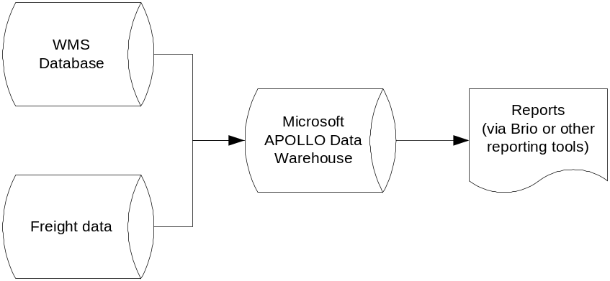
  - Functional Overview
MS operation can view reports created by Bax (requirement from MS) from Bax Club with the login ID via url : http://www.baxasiapac.com /baxclub/ . User also can base on the table definition (in section 3) to perform simple Biro query on the DC or Freight information. This is provided that user is trained and able to use Biro.Insight to perform query based on the table.

  - Technologies Used
- Apollo Data Warehouse using MS SQL 2000 database
- Biro Enterprise 6.6 Server for web report server
- Building of front-end Query using Business Intelligence tool – Brio Enterprise 6.6 Designer
- Query tool used by end-user – Biro.Insight 6.6
- BAX Club – Running on IIS server
- Security – IIS Server Running Site Certificates using HTTPS
- File Transfer Protocol (FTP)
- Functional Requirements
  - DCS Report
TBA
  - Freight Damage Report
TBA.

  - Air Freight QBR Report
TBA

- Information Flow Architecture
  - 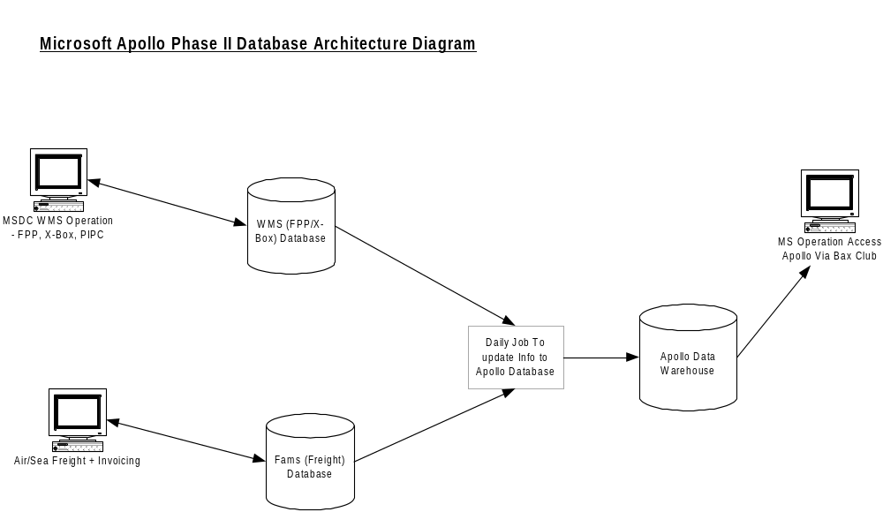Over View of Sources Of Apollo Database Diagram.

  - Database Structure Diagram
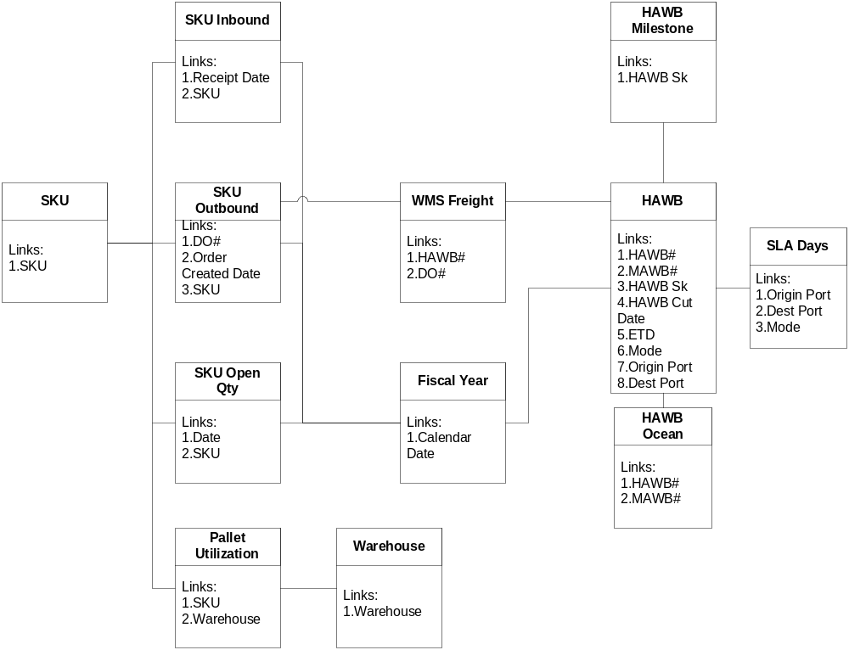

- Document Change History

Version | Change By | Date | Changes
1.00 | All Parties | 28 Jun 2003 | Based on feedback from Microsoft.

